Saturday, July 18th, 2015
3rd Annual - “ACRP Golf/Fun Day”
(Golf, Music, Euchre Tournament, Door Prizes,...and a Great BBQ)
Hosted by: The Antrim County Republican Party
“Come experience a memorable summer day in beautiful Northern Michigan at the A-Ga-Ming Golf Resort”
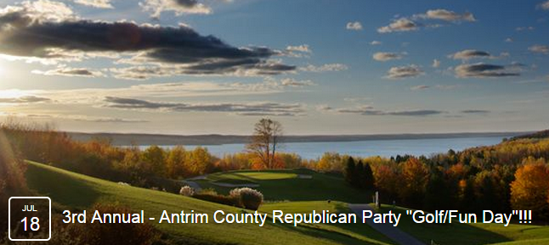
Golf Torch Course 18 Hole “Scramble” starts at 1:00 p.m. - $75/Golfer (includes $25 BBQ Dinner) (Please arrive by 12:30 p.m. or earlier to check-in & warmup at driving range or putting green.)

__Golfer #1 – Name/Town___________________________________________________________________________ (We will pair you up if you don’t have a foursome (4) to register or you simply want to golf with some new friends!!!)
__Golfer #2 – Name/Town ___________________________________________________________________________
__Golfer #3 – Name/Town___________________________________________________________________________
__Golfer #4 – Name/Town___________________________________________________________________________
__“Classic American BBQ with Homemade Sweets” - Dinner Only,…will start at 6:00 p.m. ($25 per person) Euchre Tournament will start at 2:30 p.m. and Cash Bar will open at 4:30 p.m.
Write your RSVP on the back of your CHECK made payable to “ACRP” and mail it with this completed form to: Our “ACRP - Fun Day” Outing Event, Chairman – Brad Brown;
Brad Brown · 11251 Barnes Road · Kewadin, MI · 49648 Brad’s Phone; 231-264-8233 Email; bbbandmjb@hotmail.com
***Paid for by the Antrim County Republican Party***

